Neural Network 1:  
The table below shows the architecture of the neural net:

You can use <http://alexlenail.me/NN-SVG/AlexNet.html> to get an idea of the structure if you type in the table without the MaxPooling and ZeroPadding layer**. Feel free to change the design as much as you want as long at is capture the overall structure and size of the cubes.**

Every “Layer” corresponds to a cube with size (Height x Width x (Depth)), within this cube is another smaller cube (“filter”) with size (FilterHeight x FilterWidth x log(FilterDepth)). This filter should be connected to the next layer (on the link it’s the red pyramid). The log is used as it looks stupid elsewise (on the link this is called log feature map scaling)

ZeroPadding and MaxPooling are a bit different. Those are not new layers but extend an existing layer.

Zeropadding is a bigger cube around the existing one. Maxpooling is a smaller one within the existing one. Example: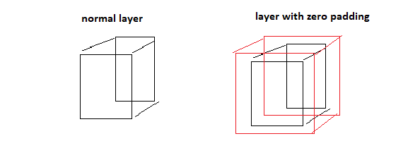

|  |  |  |  |  |  |  |
| --- | --- | --- | --- | --- | --- | --- |
| Type: | Height | Width | Depth | Filter Height | FilterWidth | FilterDepth |
| Layer | 9 | 9 | 1 | 1 | 1 | 1 |
| Layer | 7 | 7 | 15 | 1 | 1 | 15 |
| Layer | 6 | 6 | 15 | 1 | 1 | 15 |
| Maxpooling | 3 | 3 | 15 | - | - | - |
| Layer | 2 | 2 | 15 | 1 | 1 | 15 |
| ZeroPadding | 4 | 4 | 15 | - | - | - |
| Layer | 3 | 3 | 15 | 1 | 1 | 15 |
| ZeroPadding | 5 | 5 | 15 | - | - | - |
| Layer | 4 | 4 | 15 | 1 | 1 | 15 |
| ZeroPadding | 6 | 6 | 15 | 1 | 1 | 15 |
| Flatten/Vector | 50 | 1 | 1 | - | - | - |
| Dense/Vector | 5 | 1 | 1 | - | - | - |

Neural Network2:  
The instructions are equal to NeuralNetwork1 but Network2 consist of two Networks which only share the first layer and the last layer together:

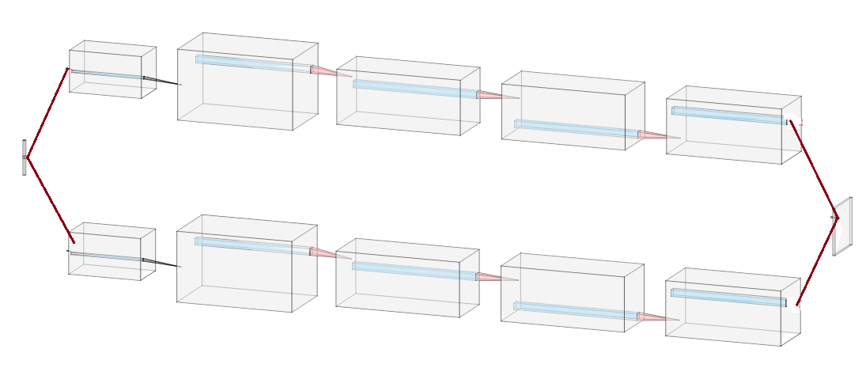

|  |  |  |  |  |  |  |
| --- | --- | --- | --- | --- | --- | --- |
| Upper Network | Height | Width | Depth | Filter Height | FilterWidth | FilterDepth |
| SharedLayer | 5 | 1 | 1 | 1 | 5 | 1 |
| ZeroPadding | 9 | 5 | 1 | - | - | - |
| Layer | 7 | 5 | 15 | 1 | 1 | 15 |
| ZeroPadding | 13 | 7 | 15 | - | - | - |
| Layer | 12 | 6 | 15 | 1 | 1 | 15 |
| Layer | 6 | 5 | 15 | 2 | 1 | 15 |
| ZeroPadding | 10 | 9 | 15 | - | - | - |
| Layer | 9 | 8 | 15 | 1 | 1 | 15 |
| ZeroPadding | 11 | 10 | 15 | - | - | - |
| Layer | 5 | 9 | 15 | 2 | 1 | 15 |
| ZeroPadding | 7 | 11 | 15 | - | - | - |
| Layer | 3 | 10 | 15 | 2 | 1 | 15 |
| ZeroPadding | 5 | 12 | 15 | - | - | - |
| Layer | 2 | 5 | 15 | 2 | 2 | 15 |
| ZeroPadding | 6 | 7 | 15 | - | - | - |
| Layer | 3 | 6 | 15 | 2 | 1 | 15 |
| Layer | 1 | 5 | 15 | 2 | 1 | 15 |
| ZeroPadding | 5 | 7 | 15 | - | - | - |
| Layer | 2 | 6 | 15 | 2 | 1 | 15 |
| Layer | 6 | 9 | 1 | - | - | - |
| SharedLayer | 9 | 9 | 1 | - | - | - |

|  |  |  |  |  |  |  |
| --- | --- | --- | --- | --- | --- | --- |
| Lower Network | Height | Width | Depth | Filter Height | FilterWidth | FilterDepth |
| SharedLayer | 5 | 1 | 1 | 1 | 5 | 1 |
| ZeroPadding | 9 | 5 | 1 | - | - | - |
| Layer | 7 | 5 | 15 | 1 | 1 | 15 |
| ZeroPadding | 13 | 7 | 15 | - | - | - |
| Layer | 12 | 6 | 15 | 1 | 1 | 15 |
| Layer | 6 | 5 | 15 | 2 | 1 | 15 |
| ZeroPadding | 10 | 7 | 15 | - | - | - |
| Layer | 9 | 6 | 15 | 1 | 1 | 15 |
| ZeroPadding | 11 | 6 | 15 | - | - | - |
| Layer | 5 | 5 | 15 | 2 | 1 | 15 |
| ZeroPadding | 7 | 7 | 15 | - | - | - |
| Layer | 3 | 6 | 15 | 2 | 1 | 15 |
| ZeroPadding | 5 | 8 | 15 | - | - | - |
| Layer | 2 | 3 | 15 | 2 | 2 | 15 |
| ZeroPadding | 6 | 5 | 15 | - | - | - |
| Layer | 3 | 4 | 15 | 2 | 1 | 15 |
| Layer | 1 | 3 | 15 | 2 | 1 | 15 |
| ZeroPadding | 5 | 5 | 15 | - | - | - |
| Layer | 2 | 4 | 15 | 2 | 1 | 15 |
| Layer | 4 | 9 | 1 | - | - | - |
| SharedLayer | 9 | 9 | 1 | - | - | - |